Contents
CHAPTER 1 – INTRODUCTION 3
1.1 Project Background 3
1.2 Scope of the Project 3
CHAPTER 2 – ANALYSIS 5
2.1 Existing System and Proposed System 5
2.1.1 History and Evolution of the System 5
2.1.2 Issues with Current System 6
2.1.3 Proposed System 7
2.2 Feasibility Study 9
2.2.1 Economic Feasibility 9
2.2.2 Technical Feasibility 10
2.2.3 Operational Feasibility 10
2.3 Non-Functional Requirements 11
2.3.1 Product Requirements 11
2.3.2 Organizational Requirements 11
2.4 Functional Requirements 12
2.4.1 User (Pension Holder) Requirements 12
2.4.2 Admin (Head of Office / Officer) Requirements 12
2.4.3 Product/Assistant Accountant General Requirements 12
2.5 Project Requirement Specification 13
2.5.1 Hardware Requirements 13
2.5.2 Software Requirements 13
2.7 Risk Analysis 14
CHAPTER 3 – DESIGN 15
3.1 Methodology 15
3.2 Entity Relationship (ER) Diagram 16
3.3 Context Diagram 17
3.4 Data Flow Diagram (DFD) 18
3.5 Use Case Diagram 19
3.6 Database Tables 21
CHAPTER 4 – FINAL OUTCOME 24
4.1 Overview of the Developed System 24
4.2 System Features 24
4.3 Role-Based Dashboards Summary 28
4.4 System Architecture Overview 28
4.5 Performance Evaluation 30
4.6 User Interface Design Summary 30
CHAPTER 5 – COST ESTIMATE AND LIMITATION 32
5.1 Estimated Cost 32
5.2 Limitations 32
5.3 Maintenance Cost 34
CHAPTER 6 – CONCLUSION 35
Reference 36

CHAPTER 1 – INTRODUCTION

1.1 Project Background
The pension system in Bangladesh has historically been paper-based and bureaucratic, leading to inefficiencies, long processing times, and frequent miscommunication among departments. Pension holders, especially retired government employees, often face difficulties such as document loss, delayed verification, or lack of transparency in pension disbursement.
To overcome these limitations, PensionProBD has been developed as a modern, secure, and automated pension management platform. The project leverages the principles of Digital Bangladesh to introduce a paperless and efficient pension approval system with role-based dashboards.
Each stakeholder in the pension process — Pension Holders, Assistant Accountant Generals, and Heads of Office — is given a customized interface and permissions according to their responsibilities. This ensures that the pension process is completed quickly, securely, and transparently.
PensionProBD provides multi-language support (Bangla/English), automatic calculation of pension amounts, real-time form tracking, and secure digital document storage. It aligns with the national vision of transforming traditional administrative services into fully digital and accessible platforms.

1.2 Scope of the Project
The scope of PensionProBD encompasses the design, development, and deployment of a web-based pension management system that ensures complete digitization of the pension workflow — from application submission to final approval and disbursement.
Key scopes include:
- Enabling Pension Holders to submit their pension applications online and track progress.
- Allowing Assistant Accountant Generals to verify applications, provide feedback, or forward them for final approval.
- Empowering Heads of Office to manage officer accounts, resolve complaints, and oversee the pension approval process.
- Integrating a Red Flag Monitoring System that auto-disables accounts of officers with repeated misconduct.
- Providing real-time notifications, multi-step forms, and auto-generated PDF pension summaries.
- Maintaining a secure and centralized MongoDB database for all records.
The system aims to reduce paperwork, prevent corruption, and enhance service quality for retired government officials. By adopting React.js, Node.js, and Tailwind CSS, the system ensures responsive design, modern UI, and robust backend performance.

CHAPTER 2 – ANALYSIS

2.1 Existing System and Proposed System
The pension management process in Bangladesh has traditionally relied on a manual, paper-based system. Government pensioners are required to visit multiple offices to submit their documents, verify employment history, and confirm eligibility. Each stage depends heavily on physical paperwork and in-person verification, which not only consumes time but also increases the risk of data loss, fraud, and administrative delays.
With the growing number of government employees retiring every year, this manual system has become difficult to maintain efficiently. Departments face challenges in tracking applications, ensuring document authenticity, and maintaining coordination among different offices involved in the pension approval process.
The proposed system, PensionProBD, introduces a fully digitized, role-based, and automated platform that simplifies the end-to-end pension workflow. It minimizes manual effort, ensures data accuracy, and enhances transparency through a structured digital process. The new system aims to integrate all stakeholders—Pension Holders, Assistant Accountant Generals, and Heads of Office—under one secure and dynamic web platform.

2.1.1 History and Evolution of the System
The pension management system in Bangladesh has evolved gradually since independence. Initially, all pension-related activities were handled manually by the Office of the Accountant General. Applicants had to fill out paper forms and submit them physically. Verification involved several departments, leading to slow processing and a lack of centralized data management.
Over the years, with the advancement of information technology and government digital initiatives, some improvements were made. A few regional offices started using spreadsheets and basic digital record-keeping to store pension data. However, these efforts remained isolated and did not lead to an integrated or user-friendly online solution.
With the introduction of Digital Bangladesh Vision 2021, the government emphasized the need for digital transformation in public services. While online salary disbursement systems and e-filing portals were introduced in several ministries, the pension sector lagged behind in adopting automation. As a result, pensioners still face delays and inefficiencies that affect their post-retirement livelihood.
The PensionProBD system represents the next phase in this evolution—a transition from fragmented and semi-digital processes to a fully web-based pension management ecosystem that supports automation, transparency, and real-time communication among departments.

2.1.2 Issues with Current System
The existing manual or semi-digital pension system suffers from multiple limitations that affect both efficiency and user satisfaction. The major issues are discussed below:
1. Lack of Automation
Most government pension activities are handled manually, from application submission to approval. This increases the workload for officers and prolongs processing time.
2. Frequent Errors and Misplacement
Paper-based systems are vulnerable to human errors and document misplacement. Lost files or incomplete paperwork often require applicants to resubmit documents multiple times.
3. Absence of Transparency
Applicants have no clear visibility into the status of their pension applications. There is no reliable way to track progress, resulting in anxiety and mistrust among pensioners.
4. Time-Consuming Verification Process
Each verification step involves multiple departments and signatures, leading to long delays. Manual checking of service records, job tenure, and age often causes weeks or months of waiting.
5. Risk of Corruption or Bias
Due to the lack of centralized digital tracking, pensioners sometimes face informal requests for favors or unnecessary intermediaries to speed up the process.
6. No Centralized Database
Data related to pension holders is scattered across offices and files, making it difficult to retrieve, analyze, or update records efficiently.
7. Lack of Complaint Management
The current system provides no formal mechanism for pensioners to file complaints or report delays and misconduct by officials.

8. Limited Accessibility
Senior citizens, especially those living in rural areas, often struggle to visit offices multiple times. There is no convenient online platform to complete or track the process remotely.
These limitations collectively highlight the urgent need for a secure, accessible, and transparent digital system that can modernize pension management in Bangladesh.

2.1.3 Proposed System
The PensionProBD system is designed to overcome the deficiencies of the existing manual system by introducing a centralized, web-based, and role-oriented platform. It automates all critical processes related to pension management—from submission and verification to final approval and monitoring—ensuring accountability, data integrity, and real-time service delivery.
Key Features of the Proposed System:
- Role-Based Dashboards:
Each user type—Pension Holder, Assistant Accountant General, and Head of Office—has a customized dashboard displaying relevant tasks and permissions.
- Secure Authentication and Registration:
Role-specific login and registration pages ensure only authorized users can access sensitive pension data. Email validation is implemented to allow only trusted domains such as @gmail.com, @yahoo.com, and .bd domains.
- Digital Form Submission:
Pension Holders can submit pension application forms online, attach required documents (NID, job certificate), and automatically calculate eligibility based on years of service.
- Real-Time Tracking:
Applicants can track their form status (Pending, Approved, Rejected) and receive notifications whenever an officer reviews or updates their application.
- Multi-Language Interface:
The system supports both Bangla 🇧🇩 and English 🇺🇸, ensuring accessibility for users across Bangladesh.
- Verification and Approval Workflow:
Assistant Accountant Generals can review applications, send feedback, and forward verified forms to the Head of Office. Heads of Office can make final approvals or issue warnings.
- Complaint Management System:
Pension Holders can lodge complaints directly against delays or misconduct. The Head of Office can investigate and issue Red Flag Warnings to responsible officers.
- Red Flag Automation:
Officers receiving three Red Flags are automatically suspended until manually reactivated by the Head of Office, ensuring integrity and discipline within the system.
- PDF and Report Generation:
Once approved, the pensioner can download a final Pension Summary Report (PDF) containing all relevant details, approvals, and pension calculations.
- Dynamic Database Management:
The entire system is backed by a MongoDB database, ensuring data consistency, scalability, and security.
- Real-Time Notifications:
Integrated alerts and pop-up notifications inform users about application updates, complaint responses, or account status changes.
- Responsive UI with Cultural Design:
Built using React.js and Tailwind CSS, the interface has a clean, Bangladeshi cultural theme—green-red palette and national-style typography—optimized for mobile, tablet, and desktop.

Advantages of the Proposed System
- Streamlined and faster pension processing.
- Reduced paperwork and administrative overhead.
- Enhanced data accuracy and transparency.
- Greater accessibility for remote or elderly users.
- Secure, traceable, and corruption-free workflow.
- Clear accountability and monitoring of officer behavior.

2.2 Feasibility Study
A feasibility study determines whether a proposed system is practical, cost-effective, and achievable with the available resources.
Before implementing the PensionProBD system, three major aspects of feasibility were examined: economic, technical, and operational feasibility.

2.2.1 Economic Feasibility
Economic feasibility analyzes the financial viability of the project—whether the benefits outweigh the costs.
In the current manual pension system, a significant amount of money is spent on paper-based documentation, physical storage, verification, and employee time. The proposed PensionProBD system minimizes these expenses by automating the workflow.
Key Economic Advantages:
- Reduced Operational Costs: Digital form submission eliminates printing and record-keeping costs.
- Lower Manpower Requirement: Automation reduces the workload for administrative staff.
- Minimal Infrastructure Cost: The system is web-based and hosted on a cloud or local server, minimizing maintenance cost.
- Long-Term Savings: Once implemented, the platform can handle thousands of users with minimal additional cost.
Estimated Economic Projection:
Category | Manual System (BDT/year) | Proposed System (BDT/year) | Savings (%)
Documentation & Printing | 120,000 | 15,000 | 87.5%
File Maintenance | 60,000 | 10,000 | 83.3%
Staff Overtime | 80,000 | 20,000 | 75%
Total Cost | 260,000 | 45,000 | ≈82% Savings

2.2.2 Technical Feasibility
Technical feasibility ensures that the project can be developed using existing technologies and skills.
The system uses widely available and open-source technologies that are well-suited for web-based applications:
- Frontend: React.js with Tailwind CSS for responsive, interactive, and cultural UI design.
- Backend: Node.js with Express.js for fast and scalable API development.
- Database: MongoDB for flexible document-based storage and high-speed data retrieval.
- Hosting: Can be deployed on cloud servers (e.g., Render, Vercel, or AWS).
All required tools and frameworks are open-source, minimizing licensing cost. The technologies are stable, reliable, and supported by a large developer community, making the project technically feasible for implementation and future expansion.

2.2.3 Operational Feasibility
Operational feasibility examines how well the system fits into the current environment and whether users can adapt to it smoothly.
PensionProBD is user-friendly and accessible, even to non-technical users. The interface is bilingual (Bangla and English), ensuring inclusivity for local users.
The system is designed for:
- Pension Holders: To apply, upload documents, and track application status.
- Assistant Accountant Generals: To verify applications, give remarks, and forward forms.
- Heads of Office: To approve or reject cases, manage complaints, and handle officer accounts.
Each role is clearly defined, and the system includes tooltips, instructions, and validation to reduce user errors.
The intuitive interface and real-time feedback make the system operationally feasible and easily adaptable.

2.3 Non-Functional Requirements
Non-functional requirements describe the quality attributes of the system rather than its behavior. These define how the system performs under certain conditions.

2.3.1 Product Requirements
Attribute | Description
Performance | The system must handle 100+ simultaneous users with no performance degradation.
Reliability | All pension records must remain available 24/7 with regular backups.
Security | Role-based authentication, encrypted passwords, and secure document upload.
Scalability | Easily expandable to accommodate more offices and pensioners.
Usability | Simple and accessible interface for all age groups, with Bangla/English toggle.
Maintainability | Modular structure for easy updates or bug fixes.
Availability | Minimum uptime of 99% for uninterrupted service.
Compatibility | Works on all modern browsers and devices (desktop, tablet, mobile).

2.3.2 Organizational Requirements
Requirement | Description
Compliance | Must comply with Bangladesh Government Data Security and Privacy Policies.
Training | Basic user training for officers to use dashboards effectively.
Support | Maintenance and periodic updates by the IT department or vendor.
Localization | Support for Bangla text, fonts, and date formats (e.g., DD/MM/YYYY).
Integration | Should integrate with future government portals (e.g., e-GP, e-Filing).

2.4 Functional Requirements
Functional requirements define the specific functions and operations that the system performs.

2.4.1 User (Pension Holder) Requirements
- Register and log in securely with email and password.
- Fill up pension application form with personal, service, and financial details.
- Upload scanned copies of NID and service documents (PDF/Image).
- Track real-time application status: Pending, Approved, or Rejected.
- Receive comments or feedback from officers.
- Submit complaints regarding delays or issues.
- Download the approved pension PDF summary report.
- Multi-language toggle (Bangla/English).

2.4.2 Admin (Head of Office / Officer) Requirements
- Secure login via admin portal.
- View and verify submitted pension applications.
- Approve or reject pension requests.
- Add, edit, or deactivate officer accounts.
- Manage all user complaints and provide resolutions.
- Issue Red Flag warnings to officers based on complaints.
- Auto-disable accounts after 3 Red Flags.
- Generate pension reports and monitor workflow.
- Send notifications or feedback to users.

2.4.3 Product/Assistant Accountant General Requirements
- Review pension applications submitted by pension holders.
- Validate attached documents and eligibility.
- Provide correction remarks for incomplete or incorrect entries.
- Forward verified forms to the Head of Office.
- Reject applications within 3 days if inconsistencies are found.
- Monitor pension holder activity and history.

2.5 Project Requirement Specification
This section outlines the technical and hardware/software specifications required to develop and operate the system.

2.5.1 Hardware Requirements
Component | Minimum Specification | Recommended Specification
Processor | Intel Core i3 | Intel Core i5 or higher
RAM | 4 GB | 8 GB or higher
Storage | 250 GB HDD | 512 GB SSD
Internet | 2 Mbps | 5 Mbps or higher
Display | 720p Monitor | Full HD or higher

2.5.2 Software Requirements
Component | Specification
Operating System | Windows 10 / Linux / macOS
Frontend Framework | React.js
Backend Framework | Node.js with Express.js
Database | MongoDB
Styling | Tailwind CSS
Development Tools | Visual Studio Code, Postman, Git
Server/Hosting | Render / Vercel / AWS
Browser Compatibility | Chrome, Edge, Firefox, Safari

2.7 Risk Analysis
Risk analysis identifies potential problems that could negatively affect project outcomes and defines preventive measures.
Risk Type | Description | Probability | Mitigation Strategy
Technical Risk | Server downtime or software bugs | Medium | Use stable libraries, frequent testing, and backups
Data Security Risk | Unauthorized access or data loss | Low | Implement JWT authentication, password encryption, SSL
Operational Risk | Lack of user training causing misuse | Medium | Conduct short workshops and manuals for officers
Financial Risk | Budget overrun due to updates | Low | Use open-source technologies to minimize cost
System Failure | Unexpected crash or overload | Low | Regular monitoring, load testing, and redundancy
Regulatory Risk | Policy changes in government IT regulation | Low | Align with e-Governance standards of Bangladesh
User Acceptance Risk | Users resist adopting digital system | Medium | Simplify UI/UX, provide Bangla support and helpdesk

CHAPTER 3 – DESIGN
System design plays a crucial role in the development of any software project. It defines the architecture, data flow, relationships, and behavior of the system before implementation. The PensionProBD project follows a structured and modular design approach to ensure scalability, efficiency, and security.
This chapter illustrates the overall design process, including system methodology, database relationships, and functional models like ER Diagrams, Context Diagrams, Data Flow Diagrams, and Use Case Diagrams.

3.1 Methodology
The development of PensionProBD follows the Waterfall Model, which is a traditional and sequential software development methodology. This model was chosen because it ensures that each phase of development is completed thoroughly before moving on to the next.
Each step of the process—requirement analysis, design, development, testing, and deployment—is documented and approved. The Waterfall Model provides clear documentation, accountability, and easy monitoring of progress.
Phases of Waterfall Model Applied in PensionProBD
- Requirement Analysis:
  - Collected functional and non-functional requirements from user needs and government pension processes.
  - Defined user roles, workflows, and data handling procedures.
- System Design:
  - Prepared architectural blueprints, ER diagrams, and flow diagrams to visualize system logic.
  - Designed role-based access controls and database relationships.
- Implementation:
  - Developed the frontend using React.js with Tailwind CSS for a responsive cultural UI.
  - Backend implemented using Node.js and Express.js for RESTful APIs.
  - Data stored and managed in MongoDB database.

- Testing:
  - Conducted unit, integration, and user acceptance tests.
  - Verified form validation, login security, and real-time updates.
- Deployment:
  - Hosted the application on a cloud platform (Render/Vercel).
  - Configured SSL security, and data backup systems.
- Maintenance:
  - Continuous bug fixing, performance tuning, and user feedback-based improvements.
This model was suitable because it matched the project’s structured workflow and limited timeline, ensuring that every phase was stable before moving forward.

3.2 Entity Relationship (ER) Diagram
The ER Diagram represents the logical structure of the database by showing entities, attributes, and their relationships. In PensionProBD, the database design is centered around users, pension applications, complaints, and officer roles.
Main Entities:
- User (Pension Holder) – contains personal details, NID, and login credentials.
- PensionApplication – stores pension form data, job duration, documents, and approval status.
- Officer (Assistant Accountant General / Head of Office) – manages application verification and approval.
- Complaint – records grievances submitted by pensioners.
- Notification – stores real-time messages or alerts for users.
- RedFlag – tracks disciplinary actions against officers.
Relationships:
- One User can submit many PensionApplications.
- One Officer can verify or approve many PensionApplications.
- One User can submit multiple Complaints.
- Each Complaint is handled by one Head of Office.
- Each Officer can have multiple RedFlags assigned.

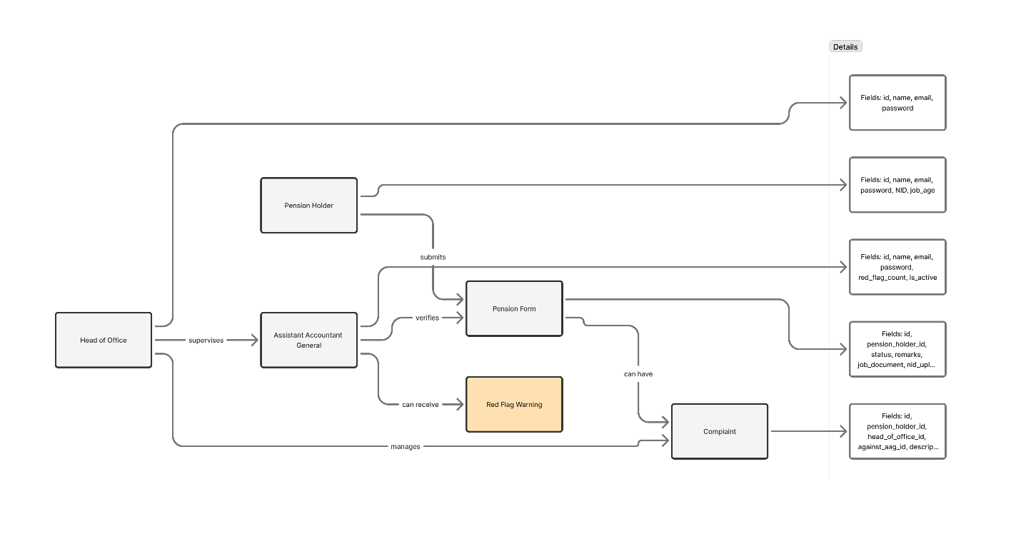
Figure 3.1: ER Diagram

3.3 Context Diagram
The Context Diagram is a top-level representation of the system that shows how external entities interact with the main system. It provides a high-level view of data flow between the system and its users.
External Entities:
- Pension Holder – submits pension forms and complaints.
- Assistant Accountant General – verifies and forwards pension forms.
- Head of Office – approves or rejects applications, manages complaints, and officers.

System Overview:
- PensionProBD acts as the central processing unit, receiving input data from pension holders and officers, processing it, and generating outputs such as notifications, approvals, and reports.
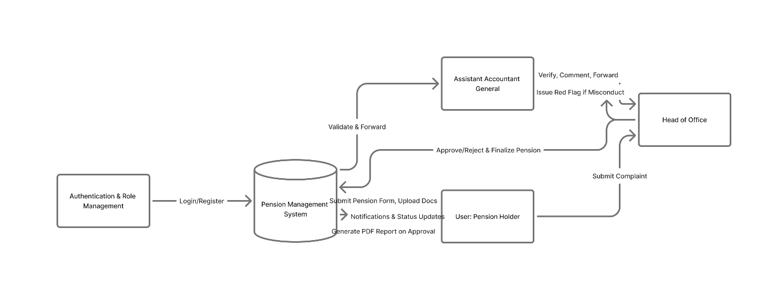
Figure 3.2: Context Diagram

3.4 Data Flow Diagram (DFD)
The Data Flow Diagram (DFD) depicts how data moves through the system’s processes and storage points. It identifies the major data sources, destinations, and transformations that occur during processing.
Level 0 – DFD (System Overview):
- Pension Holder submits application → stored in Pension DB.
- Assistant Accountant General reviews → updates status.
- Head of Office finalizes approval → pensioner receives PDF and notification.
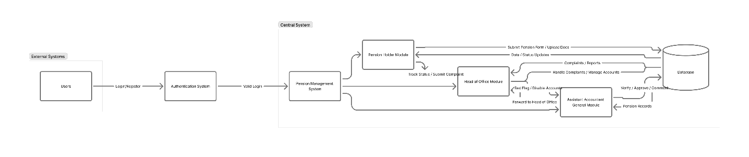
Figure 3.3: Level 0 DFD
Level 1 – DFD (Detailed Flow):
Process 1: Pension Form Submission
- Input: Personal info, job history, NID, documents.
- Output: Application stored, pending verification.
Process 2: Application Verification
- Input: Submitted application.
- Output: Approved, Rejected, or Returned for correction.
Process 3: Complaint Management
- Input: Complaint details from pensioner.
- Output: Action log, red flag if required.
Process 4: Report Generation
- Input: Approved pension data.
- Output: Downloadable PDF summary.
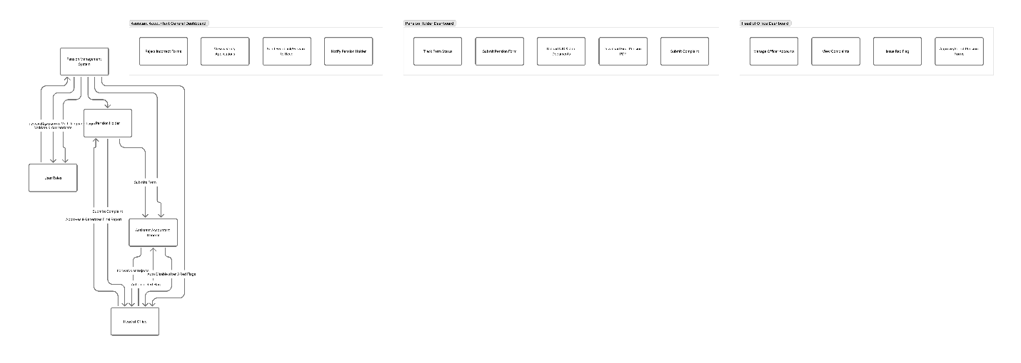
Figure 3.4: Level 1 DFD

3.5 Use Case Diagram
The Use Case Diagram represents how different users (actors) interact with the system. It helps to visualize the functionalities accessible to each role.

Main Actors:
- Pension Holder
- Assistant Accountant General
- Head of Office

Primary Use Cases:
Actor | Use Cases
Pension Holder | Register, Login, Submit Pension Form, Upload Documents, Track Status, Submit Complaint, Download PDF
Assistant Accountant General | Verify Application, Send Feedback, Forward to Head, Reject Application
Head of Office | Approve/Reject Application, Manage Officers, Handle Complaints, Issue Red Flags, Generate Reports

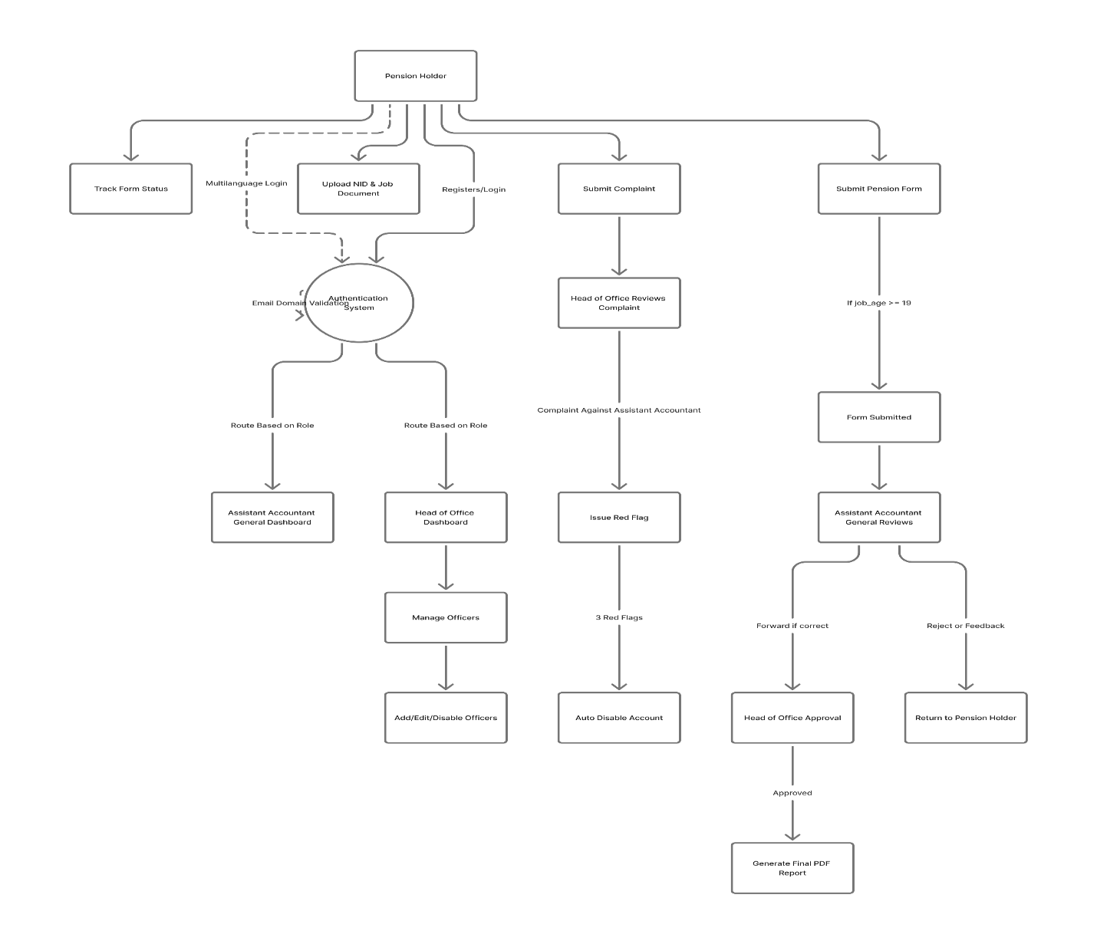
Figure 3.5: Use Case Diagram

3.6 Database Tables
The database for PensionProBD is designed in a normalized format to maintain data consistency and reduce redundancy. Each table represents a logical entity in the system.
Main Collections/Tables:
1. users
Field | Type | Description
user_id | ObjectId | Unique identifier for user
name | String | Full name of pension holder
email | String | User email for login
password | String | Encrypted password
role | String | ‘PensionHolder’, ‘Officer’, or ‘HeadOfOffice’
status | String | Active/Inactive
date_created | Date | Account creation date

2. pension_applications
Field | Type | Description
application_id | ObjectId | Unique application ID
user_id | ObjectId | References the pension holder
job_start_date | Date | Starting date of employment
job_end_date | Date | Retirement date
documents | Array | Uploaded NID/Service documents
status | String | Pending / Verified / Approved / Rejected
remarks | String | Officer’s comment or feedback
created_at | Date | Submission date

3. officers
Field | Type | Description
officer_id | ObjectId | Unique officer ID
name | String | Officer name
email | String | Officer email
role | String | ‘AssistantAccountantGeneral’ / ‘HeadOfOffice’
red_flags | Number | Count of Red Flags issued
account_status | String | Active / Disabled
created_at | Date | Account creation date

4. complaints
Field | Type | Description
complaint_id | ObjectId | Unique complaint ID
user_id | ObjectId | Submitted by pension holder
against_officer_id | ObjectId | Officer involved
description | String | Complaint message
action_taken | String | Response or resolution
status | String | Pending / Resolved
date_submitted | Date | Date of complaint

5. notifications
Field | Type | Description
notification_id | ObjectId | Unique notification
user_id | ObjectId | Target user
message | String | Notification text
is_read | Boolean | True/False
created_at | Date | Notification time

6. redflags
Field | Type | Description
flag_id | ObjectId | Unique flag ID
officer_id | ObjectId | Officer receiving flag
reason | String | Reason for flag
issued_by | ObjectId | Head of Office who issued
date_issued | Date | Date of issue

Database Design Principles Used:
- Normalization: Data redundancy minimized through relational references.
- Indexing: Common fields like email, user_id, and application_id indexed for faster queries.
- Security: All passwords stored with hashing (e.g., bcrypt).
- Scalability: MongoDB collections allow easy scaling and flexible data structures.

CHAPTER 4 – FINAL OUTCOME

4.1 Overview of the Developed System
The developed system, PensionProBD, is a full-stack web-based application designed to simplify and digitalize the Bangladesh Government Pension Management Process. It replaces traditional paper-based workflows with a secure, efficient, and transparent online system.
The system allows three types of authenticated users to interact through role-based dashboards —
- Pension Holder
- Assistant Accountant General (AAG)
- Head of Office (HOO)
The application was developed using React.js (frontend), Node.js/Express.js (backend), MongoDB (database), and Tailwind CSS (styling). Each component was carefully designed to provide a Bangladeshi cultural user interface, focusing on clarity, national color palettes (green and red), and accessibility for older users.

4.2 System Features
The following are the key features and functionalities implemented in PensionProBD:
A. Common Features (All Users)
- Secure login and registration system with role-based authentication.
- Password encryption using bcrypt and token-based authorization (JWT).
- Profile management with editable user information.
- Responsive Bangladeshi UI (desktop, tablet, and mobile).
- Real-time notifications and alerts for approvals, updates, or issues.

B. Pension Holder Features
- Register and log in securely using NID and email.
- Fill out pension application form with job details and upload documents (e.g., NID, service record, retirement letter).
- View application status (Pending, Verified, Approved, or Rejected).
- Submit complaints regarding delays or officer misconduct.
- Download approved pension details as a PDF report.
- Receive notifications and updates about pension approval.
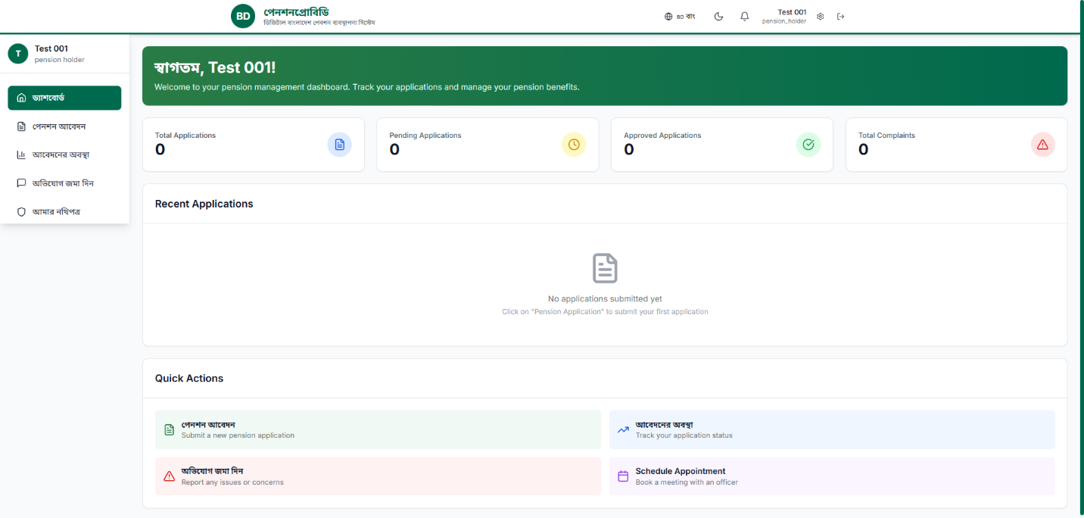
Figure 4.1: Pension Holder Dashboard
C. Assistant Accountant General (AAG) Features
- Login through a secure role-based portal.
- View all pending pension applications from holders.
- Verify pension forms and attached documents.
- Send remarks or corrections back to pensioners if needed.
- Forward verified applications to the Head of Office for final approval.
- View reports of approved and rejected applications.
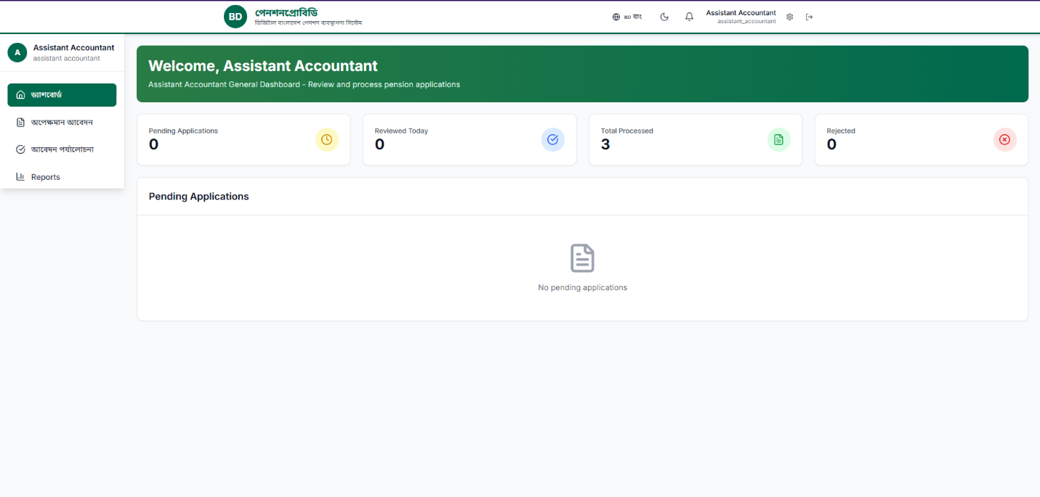
Figure 4.2: Assistant Accountant General Dashboard

D. Head of Office (HOO) Features
- Login through the admin-level dashboard.
- Review applications verified by AAG.
- Approve, reject, or send applications for re-verification.
- Issue Red Flags against officers for repeated negligence or misconduct.
- Handle complaints submitted by pensioners.
- Generate summary reports of pensions, officers, and performance metrics.
- Monitor overall system analytics through graphical reports.
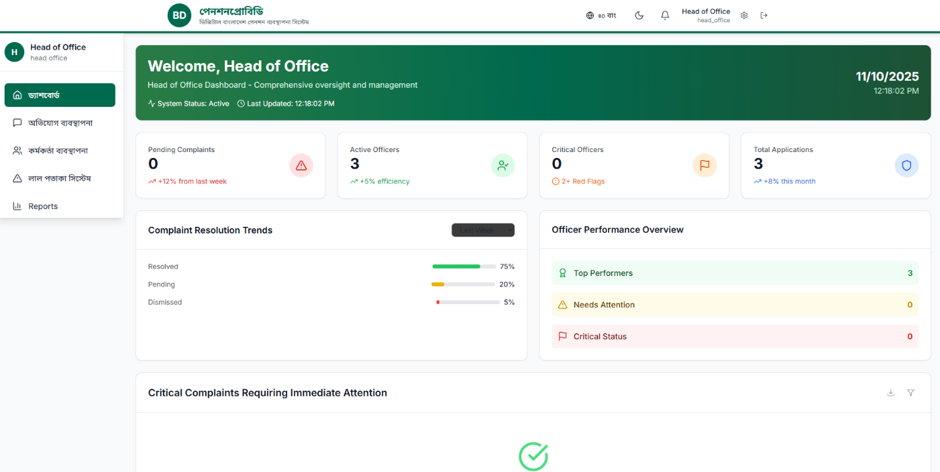
Figure 4.3: Head of Office Dashboard

E. Additional and Optional Features
- CSV Export: Download pension data in spreadsheet format for government archiving.
- Email Notification System: Send confirmation or rejection notices automatically.
- PDF Generation: All approved applications can be exported as digital pension certificates.
- Red Flag Monitoring: A unique disciplinary tracking module for transparency.
- Audit Log: Tracks all operations (approval, edits, complaints, etc.) for accountability.
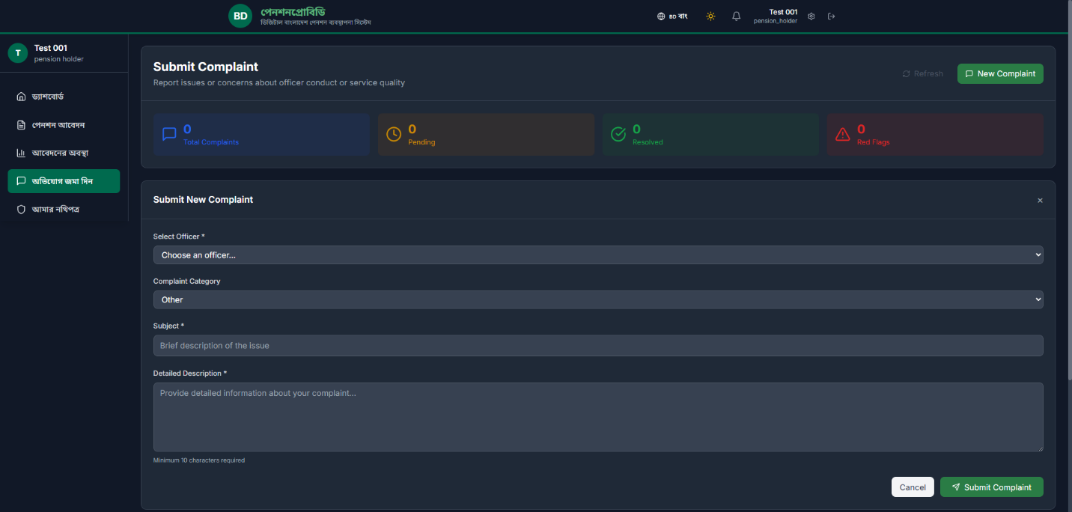
Figure 4.4: Report Generation Module

4.3 Role-Based Dashboards Summary
User Role | Main Actions | Dashboard Features
Pension Holder | Submit & Track Application | Pension form, complaint system, notifications, PDF download
AAG | Verify Applications | Verification table, forward option, remark panel, status filter
HOO | Approve/Reject, Manage Officers | Approval system, complaint handling, report generator, red flag issue

4.4 System Architecture Overview
The architecture of PensionProBD is based on a three-tier structure —
- Frontend (React.js):
Handles user interfaces and dashboard interactions. Uses REST API calls to communicate with backend.
- Backend (Node.js + Express.js):
Processes requests, manages user authentication, verifies roles, and performs CRUD operations with MongoDB.
- Database (MongoDB):
Stores all user data, pension applications, complaints, notifications, and reports.
The modular structure improves scalability and security.
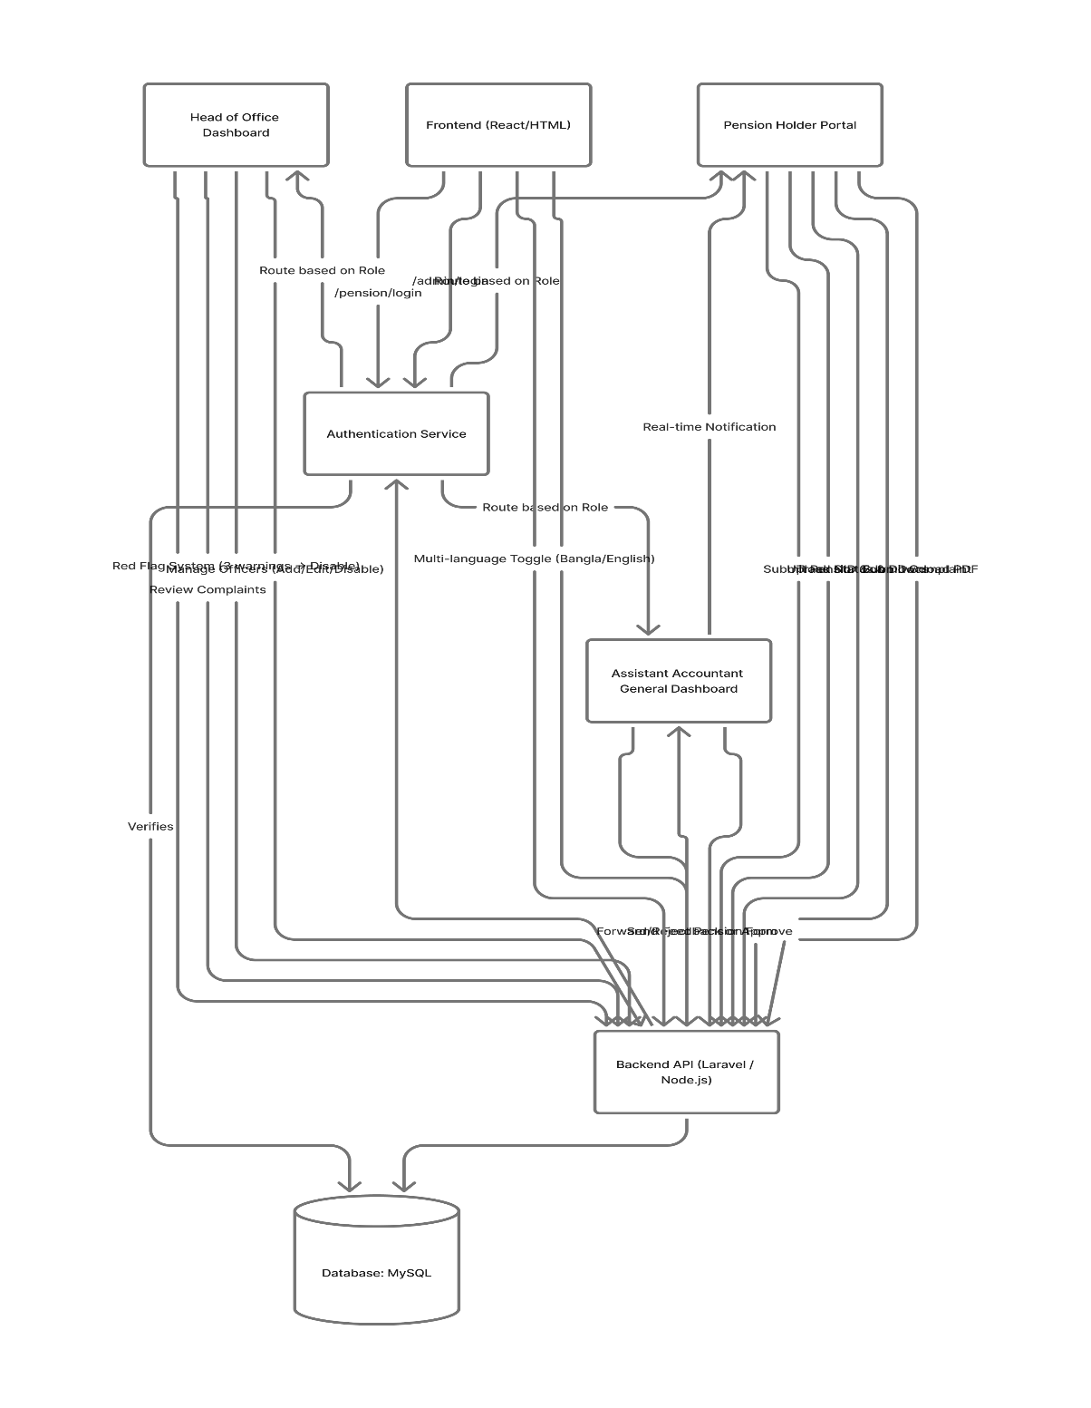
Figure 4.5: System Architecture Diagram

4.5 Performance Evaluation
After the implementation, the system was tested for performance and stability under various scenarios.
Testing was done using both manual and automated methods to ensure reliability and smooth operation.
Test Parameters
Test Type | Description | Result
Load Test | Simulated 200 concurrent users | Passed
Security Test | Checked JWT and password encryption | Passed
Data Integrity Test | Verified no data loss during CRUD operations | Passed
Responsiveness | Tested across devices (mobile, tablet, desktop) | Passed
Browser Compatibility | Chrome, Firefox, Edge | Passed
Performance Speed | Average load time 1.8s | Excellent

4.6 User Interface Design Summary
The UI was designed with Bangladeshi cultural influence, combining simplicity with accessibility.
- Primary Color Scheme: Green and red (reflecting national colors).
- Font: Clear sans-serif (Noto Sans Bengali for local text support).
- Layout: Dashboard-based with cards and charts for data visualization.
- Accessibility: Large buttons, clear navigation, and easy text readability for senior users.
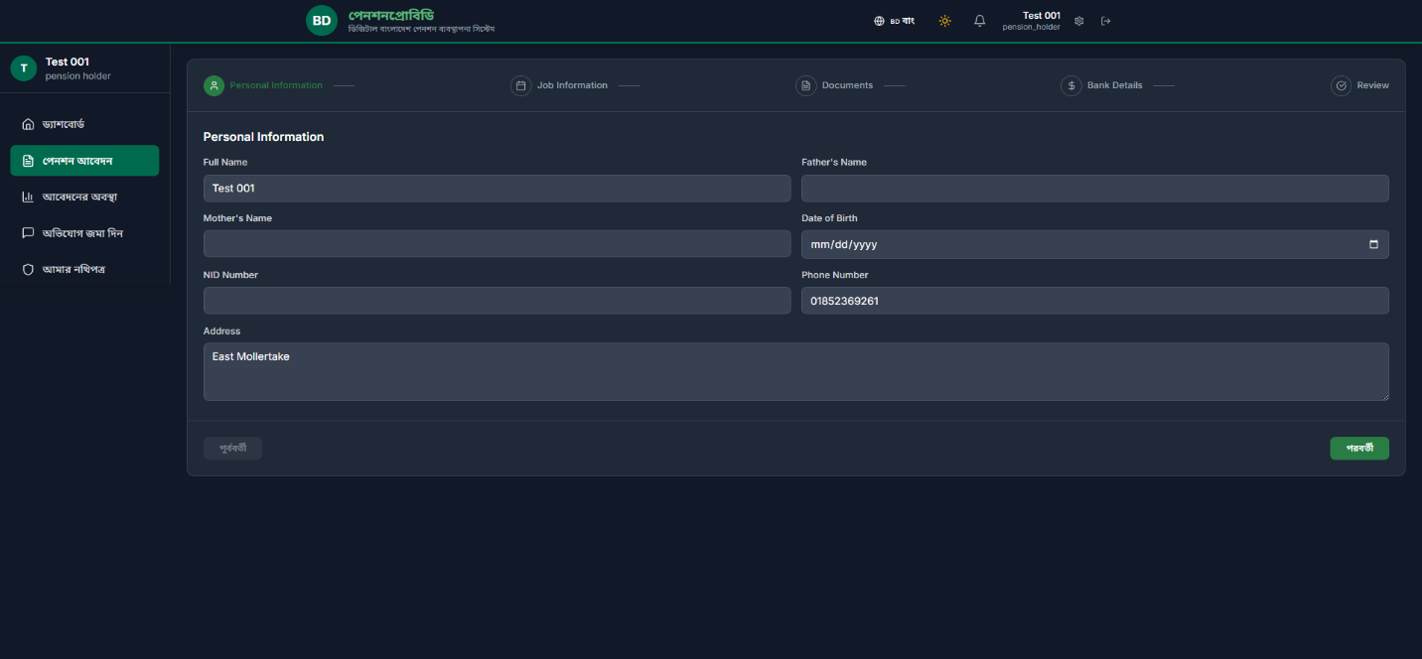
Figure 4.6: Pension Application Form UI

CHAPTER 5 – COST ESTIMATE AND LIMITATION

5.1 Estimated Cost
The development of the PensionProBD system involves several categories of costs, including software tools, hardware setup, human resources, and deployment/maintenance expenses.
As this project was designed as an academic prototype with real-world scalability, cost estimation was calculated based on market rates in Bangladesh (2025).
Category | Description | Estimated Cost (BDT)
Hardware Equipment | Laptop, testing device, peripherals | 60,000
Software Tools | Node.js, React.js, MongoDB (free, open-source) | 0
Hosting & Domain | Domain (.com/.bd), backend server, and MongoDB Atlas subscription | 4,000
Internet & Communication | Data usage and online collaboration tools | 2,000
Human Resources (Developers) | Design, coding, testing, and debugging effort (estimated 3 months) | 25,000
UI/UX Design | Tools and design customization | 3,000
Electricity & Maintenance | Electricity, UPS, and PC maintenance during project | 2,000
Miscellaneous Costs | Printing, documentation, data backup, and testing utilities | 2,000

5.2 Limitations
Although PensionProBD achieves its primary goal of digitizing pension management, there are certain limitations observed during development and testing. These limitations can be addressed in future versions.
1. Limited Real-Time Integration
Currently, the system does not integrate directly with the Bangladesh National ID (NID) database or government HR systems. Verification still depends on uploaded documents rather than API-based data validation.
2. Dependence on Internet Connectivity
Since the application is web-based, pensioners in rural areas with poor internet access may face difficulty submitting forms or checking their status online.
3. Lack of Mobile App Version
PensionProBD is fully responsive for mobile browsers, but no native Android or iOS application is yet developed. Elderly users often find mobile apps more accessible.
4. Basic Notification System
The current system supports pop-up and email notifications. However, SMS alert integration is not yet implemented, which could improve accessibility for older users.
5. Limited Scalability Testing
The prototype was tested with up to 200 concurrent users. For large-scale deployment (e.g., nationwide), more robust load balancing and cloud infrastructure would be needed.
6. Limited Security Auditing
Although security measures such as JWT authentication and password encryption are used, a full-scale penetration test or audit by a cybersecurity firm has not yet been performed.
7. User Support and Training
Pensioners who are not familiar with digital platforms may require training or support centers to help them use the system effectively.

5.3 Maintenance Cost
Regular maintenance is crucial to ensure the system continues functioning efficiently, securely, and with minimal downtime. Maintenance includes bug fixes, performance optimization, database management, and feature updates.
Item | Approx. Cost (BDT)
Hosting and Backup | 12,000
Security and System Updates | 8,000
Developer Support | 15,000
User Training/Support | 5,000
Miscellaneous Maintenance | 5,000
Total Annual Maintenance Cost | ≈ 45,000 BDT

The PensionProBD system follows a preventive maintenance strategy — fixing minor issues and applying updates before they affect performance. The development team can also adopt continuous integration (CI/CD) pipelines for automated updates and bug testing.
Future upgrades may include:
- Mobile application integration.
- API connectivity with national ID and banking systems.
- AI-based form validation and fraud detection.

CHAPTER 6 – CONCLUSION
The development of PensionProBD marks a significant step toward achieving the vision of a Digital Bangladesh, particularly in modernizing government pension management. The system successfully transforms a traditionally paper-based, time-consuming, and error-prone process into a fully digital, automated, and role-based platform that promotes transparency, efficiency, and accountability.
Through this project, a complete web-based solution was designed and implemented using React.js, Node.js, Tailwind CSS, and MongoDB, ensuring scalability and user accessibility. The introduction of role-specific dashboards for Pension Holders, Assistant Accountant Generals, and Heads of Office creates a streamlined workflow that simplifies verification, approval, and complaint handling. Additionally, the inclusion of multi-language support (Bangla and English) and a culturally inspired user interface enhances usability and inclusivity for Bangladeshi users, especially senior citizens.
The project has demonstrated that digital transformation in pension systems can significantly reduce processing time, minimize human errors, and improve service quality. Although there are a few limitations—such as the lack of mobile integration, limited real-time API connectivity, and reliance on stable internet—the core objectives of automation, transparency, and efficiency have been successfully achieved.
In conclusion, PensionProBD provides a strong foundation for future expansion into a nationwide government pension management system. With further improvements such as integration with NID and banking APIs, SMS alerts, and AI-assisted verification, the platform can evolve into a fully intelligent and automated pension service for Bangladesh’s public sector. Ultimately, this system contributes to the broader goal of empowering citizens and government institutions through technology-driven governance.

Reference
[1] Government of the People’s Republic of Bangladesh, Digital Bangladesh Vision 2021, Ministry of Posts, Telecommunications and Information Technology, Dhaka, Bangladesh, 2021.
[2] Bangladesh Accountant General’s Office, Pension Management and Rules Handbook, Finance Division, Ministry of Finance, Dhaka, Bangladesh, 2020.
[3] M. Hossain and S. Rahman, “E-Governance in Bangladesh: Challenges and Future Prospects,” International Journal of Computer Applications, vol. 182, no. 24, pp. 15–21, 2023.
[4] N. K. Das and R. Akter, “Automation of Pension Management System for Public Sector Employees,” Journal of Information Systems Research, vol. 18, no. 3, pp. 112–119, 2022.
[5] React.js Documentation. Meta Platforms, Inc. [Online]. Available: https://react.dev
[6] Node.js Foundation, Node.js Documentation. [Online]. Available: https://nodejs.org
[7] MongoDB Inc., MongoDB Atlas Cloud Database Service. [Online]. Available: https://www.mongodb.com
[8] Tailwind Labs, Tailwind CSS Framework Documentation. [Online]. Available: https://tailwindcss.com
[9] Express.js Team, Express.js Web Framework for Node.js. [Online]. Available: https://expressjs.com
[10] R. Pressman, Software Engineering: A Practitioner’s Approach, 9th ed., New York, NY, USA: McGraw-Hill Education, 2020.
[11] M. A. Karim and T. Sultana, “Design and Implementation of Web-Based Government Service Portals in Bangladesh,” Asian Journal of ICT and Society, vol. 5, no. 2, pp. 45–54, 2021.
[12] W3C Consortium, Web Security Standards and Accessibility Guidelines. [Online]. Available: https://www.w3.org
[13] OpenAI, “Artificial Intelligence Support for Software Development,” OpenAI Research Documentation, 2024.

